Account Management
This functional specification describes how users create, view, update, activate, and deactivate financial accounts used for transaction capture, balance tracking, search, and reporting.

Overview
Purpose: Maintain the financial accounts used throughout the system. Users can view account details, add new accounts, edit eligible information, and activate or deactivate accounts. The current balance is system-managed and cannot be edited directly.

Summary
- Account names are mandatory and unique among active accounts.
- Supported account types are Bank, Cash, Credit Card, Investment, and Loan.
- The current balance initially equals the opening balance.
- Accounts with transaction history are deactivated rather than deleted.
- Inactive accounts are excluded from normal selection unless explicitly requested.

Input
Input | Rule
Account Name | Required; unique among active accounts.
Account Type | Required; Bank, Cash, Credit Card, Investment, or Loan.
Opening Balance | Required numeric value used to initialise the current balance.
Active Status | Indicates whether the account is available for normal selection.
Action | Add, Edit, Activate, or Deactivate.

Output
- Account list showing active accounts and their current balances.
- Saved account record containing the validated account details.
- Current balance set equal to the opening balance for a newly created account.
- Confirmation message after a successful add, edit, activation, or deactivation.
- Field-specific error message when required data, account type, balance, or name uniqueness validation fails.

Activity Diagram
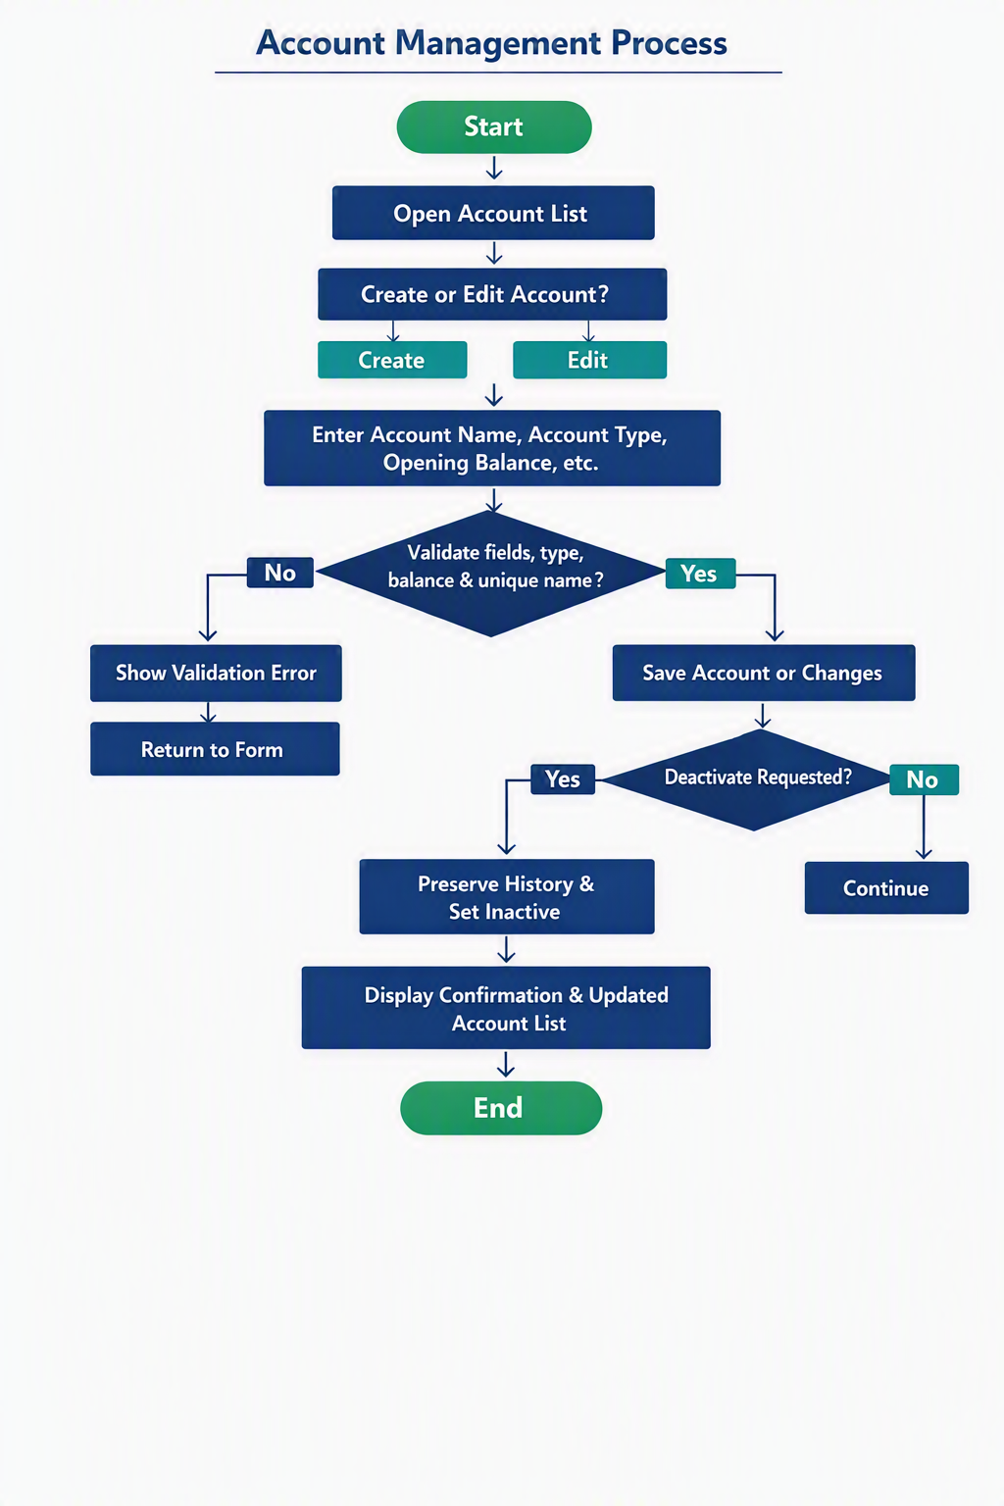
Figure 1 — Account Management activity diagram.

Screen and Process Flow
Step | User/System Behaviour
1 | User opens Account List; system displays active accounts and current balances.
2 | User selects Add, Edit, Activate, or Deactivate.
3 | System validates name, type, balance, and uniqueness.
4 | Valid data is saved and confirmation is shown; invalid data remains unsaved with an error.

Fields: Account Name, Account Type, Opening Balance, Current Balance (read-only), Active Status.
Positive Test: Create a unique account; current balance equals opening balance.
Negative Test: Duplicate active name is rejected.

